www.booktrust.org.uk is a great site to use to read the blurbs of some of the books.
Race To The Frozen North | Catherine Johnson
The Apprentice Witch | James Nicol
A Child Of Books | Oliver Jeffers
Oliver And The SeaWigs | Philip Reeve
13 Story Tree House | Andy Griffiths
Ottoline | Chris Riddell
The Wild Robot | Peter Brown
Defenders: Dark Arena | Tom Palmer
Max & The Millions | Ross Montgomery
My Brother Is A Superhero | David Solomons
Cliff Hanger | Jacqueline Wilson
Tales Of Olga Da Polga | Michael Bond
Tom’s Midnight Garden | Phillipa Pearce
Krindlekrax | Philip Ridley
Tin Tin: The Black Island | Hergé
Journey To The River Sea | Eva Ibbotson
Harry Potter And The Philiosopher’s Stone | J.K. Rowling

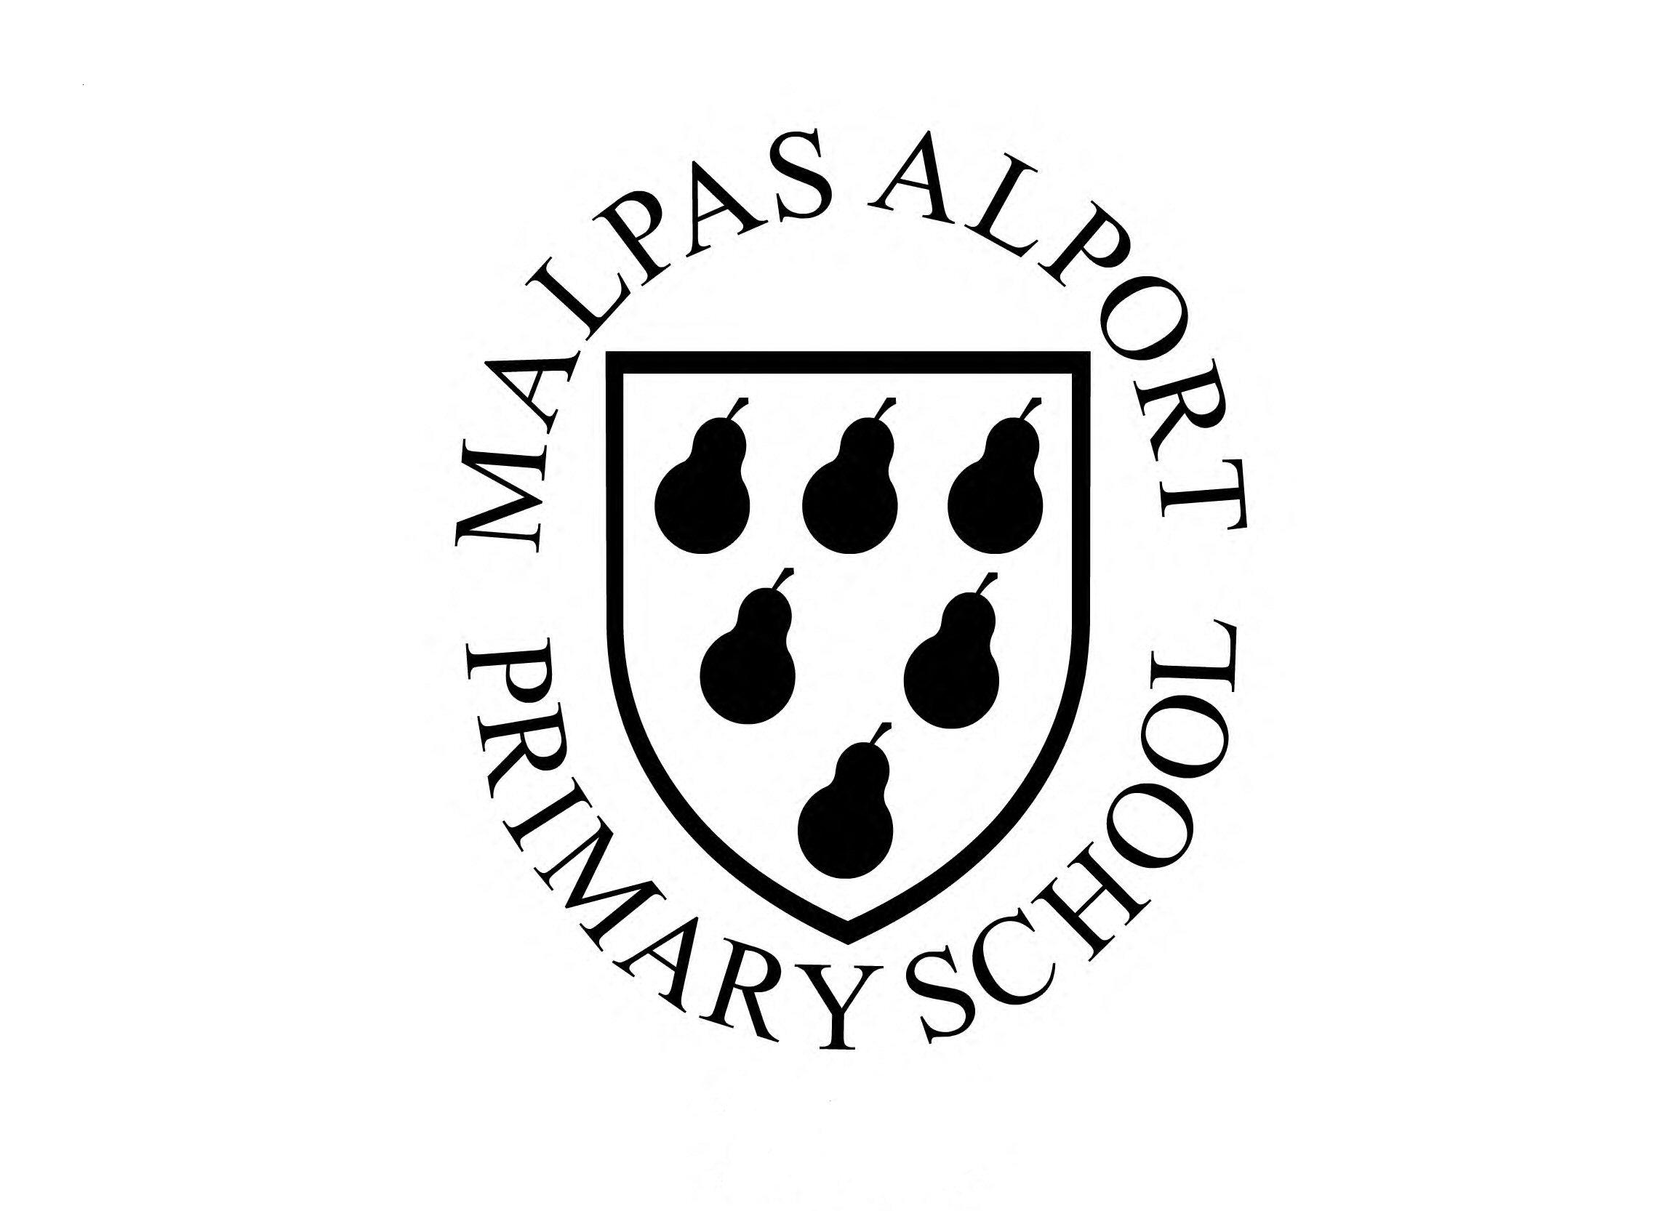
List C

Malpas Alport Endowed
Primary School

Name:____________________

50 books to read

Here is a list full of great texts for you to read including classic novels and some debuts by brilliant authors. Lots of the books are the first in a series you can get hooked on a certain character or setting and read sequel after sequel.

This list is not a challenge - these are great recommendations for books to read. Work your way through them over the year and enjoy reading!!

Title | Author | Date Completed
How To Train Your Dragon | Cressida Cowell
The Ledged Of Podkin One Ear | Kieran Larwood
The Firework Makers Daughter | Philip Pulman
Butterfly Lion | Michael Murpurgo
The Great Chocoplot | Chris Callaghan
Varjak Paw | S.F Said
Iron Man | Ted Hughes
The Boy Who Grew Dragons | Andy Shephard
Stig Of The Dump | Clive King
Charlotte’s Web | E.B. White
The Nothing To See Here Hotel | Steven Butler
Running On The Roof Of The World | Jess Butterworth
Ice Palace | Robert Swindells
There May Be A Castle | Piers Torday
You’re A Bad Man Mr Gum | Andy Stanton
Kick Off | Dan Freedman
The Accidental Billionaire | Tom McLaughlin
Dog Man | Dav Pikey
The Abominables | Eva Ibbotson
Kid Normal | Greg James
Amelia Fang | Ellen Anderson
Alex Sparrow And The Really Big Stink | Jennifer Killick
Joan Procter, Dragon Dr | Patricia Valdez
A World Of Cities | Lily Murray
Planet Omar, Accidental Trouble Magnet | Zanib Main
The Sheep Pig | Dick King Smith
The Lion, The Witch And The Wardrobe | CS Lewis
Alice’s Adventures In Wonderland | Lewis Carroll
The Witches | Roald Dahl
Railway Children | E Nesbit
Great Women Who Changed The World | Kate Pankhurst
Stuart Little | E.B. White
Famous 5 On Treasure Island | Enid Blyton

